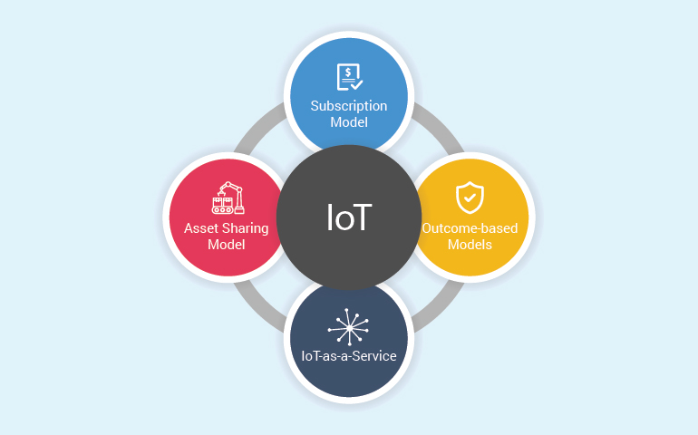**Customer -> Mobile App -> Order Placement -> Inventory Check -> AI Recommendation -> Delivery Dispatch -> Real-Time Tracking -> Delivery Confirmatio-> Web Dashboard -> Inventory Management -> Sales Analytics -> AI Insights**